# UE4 SDK simple instructions

2021-03-22 Tianqi Yang

Before use, it is recommended that the computer has the VC++ (2015-2019) program installed, and at the same time copy the 5 Dll files under the Tosystem32 compressed file to the C:\Windows\System32 path.

**1. This SDK version is suitable for UE4 4.18.3 and 4.24.3. If you want to change to another version, you need to recompile, the operation is as follows:**

①.Open the UE4 of the version you want to use

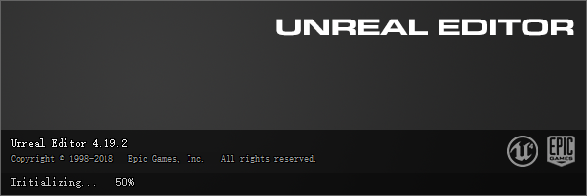

②.Create a new C++ project

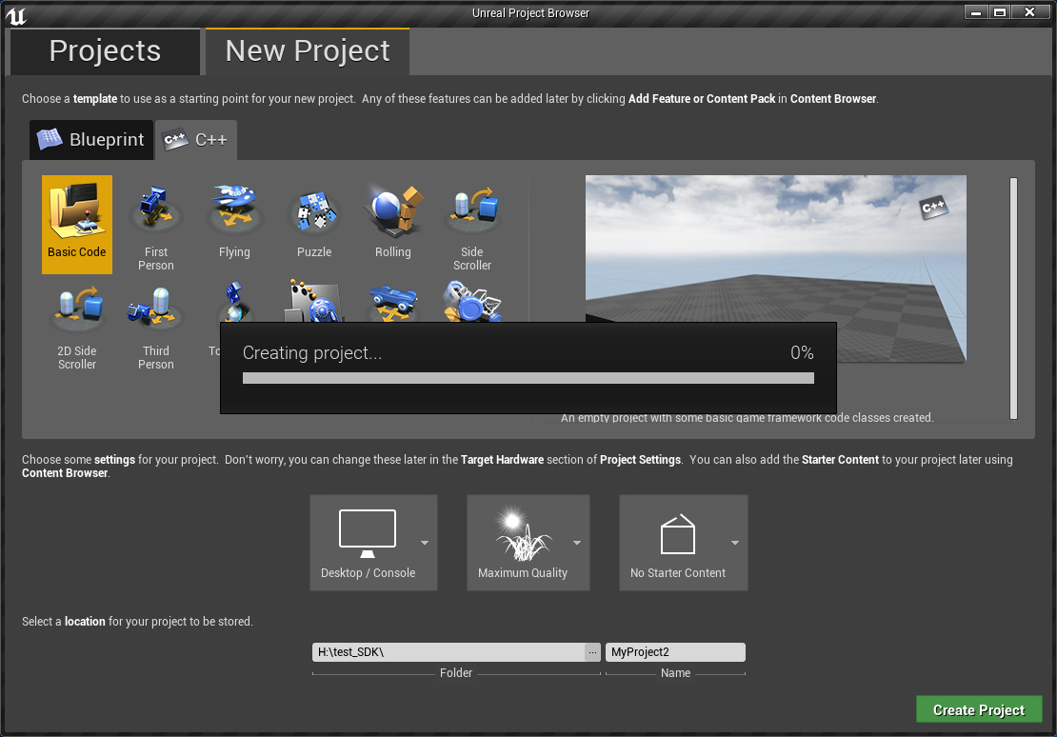

③.Recompile once

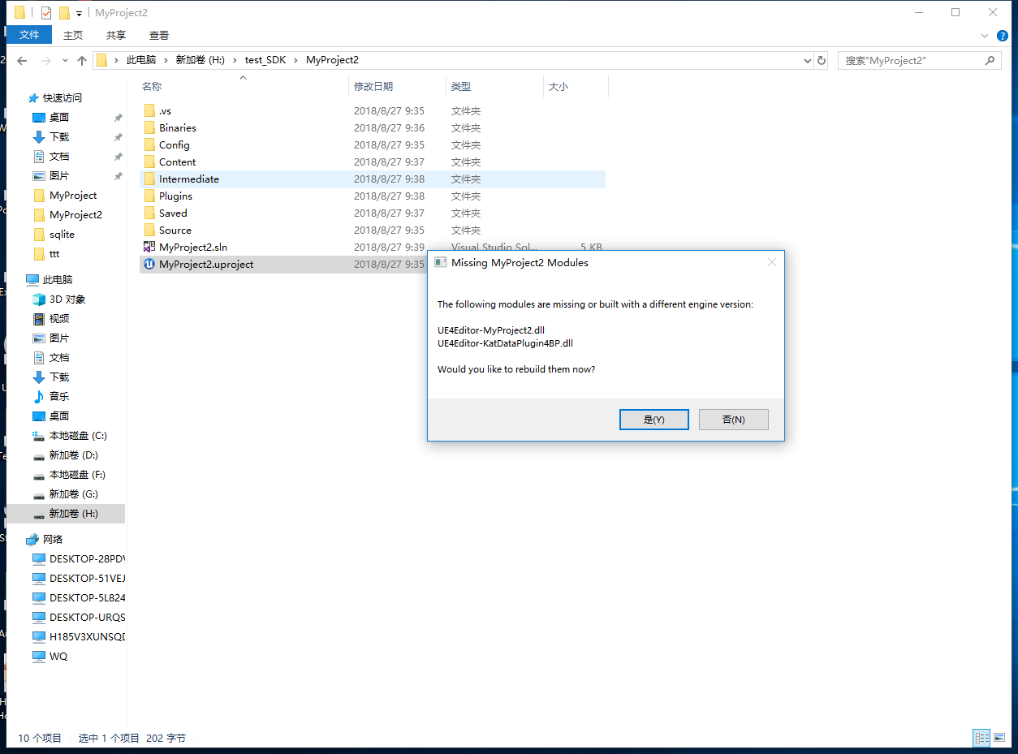

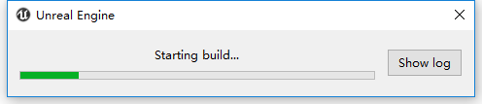

④.After the compilation is completed, the plug-in becomes the SDK plug-in of the corresponding version (version 4.19.2 is taken as an example), and then the plug-in can be placed under the project file of the corresponding project

**2. Create a Plugins folder in the project file directory, and put the corresponding version of the SDK Plugins into the folder.**

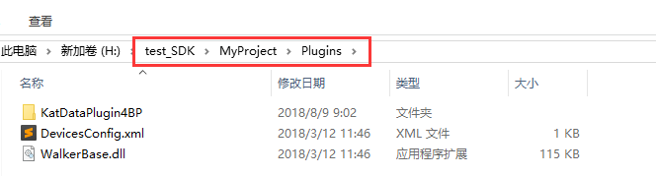

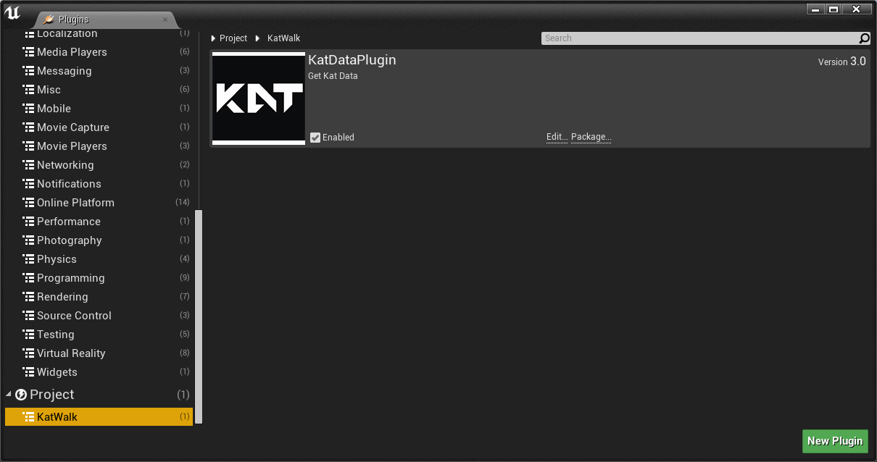

**3. Open your own Pawn class, change its parent class to Character class (in order to simulate collisions, etc., users can also create a new Character class by yourself), and add an Arrow in the directory (this is the direction of simulated walking).**

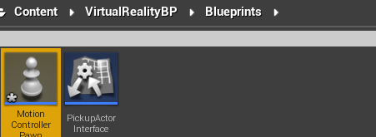



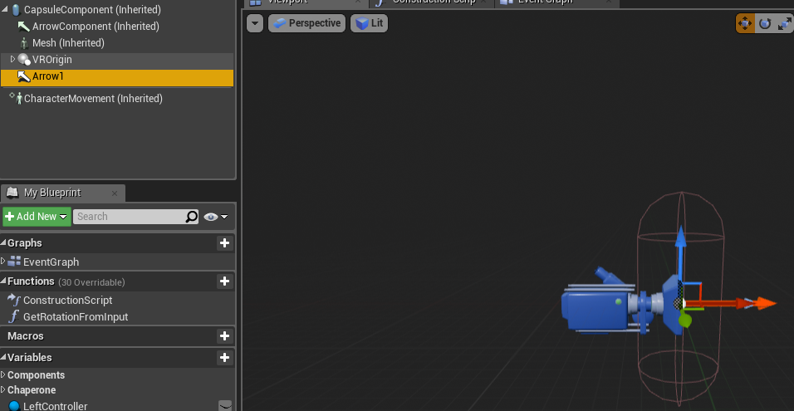

**4. Add a branch in BeginPlay and define a variable to store the rotation value of the rotating rod.**

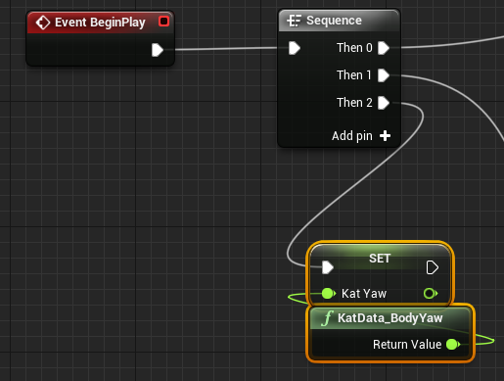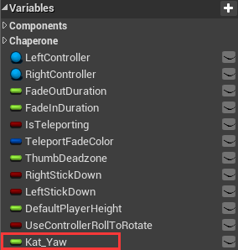

**5.Add a new branch in Event Tick to move the character (The movement direction depends on the direction of the rotation rod), and rotate it according to the direction of the rotation rod.**

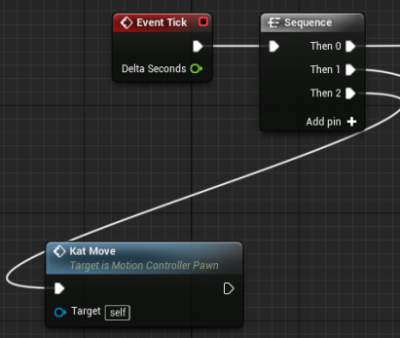

Kat Move is a custom method for setting the parameters. In order to implement it pls follow the steps below

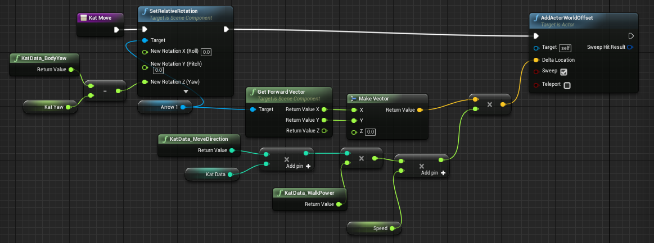

Analysis:

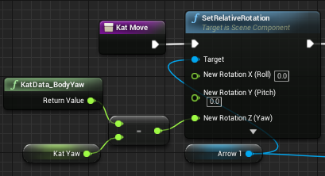   
Set the movement direction:

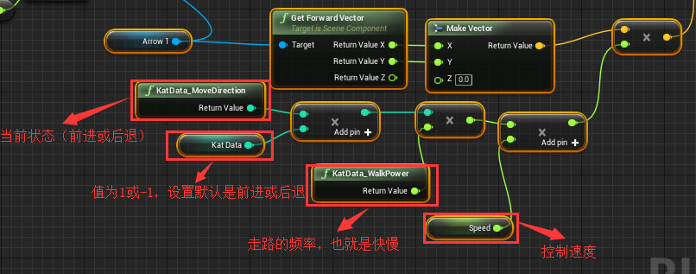

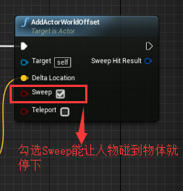

**6.Create a new GameModel to modify the Pawn Class and assign it to the default GameModel Override.**

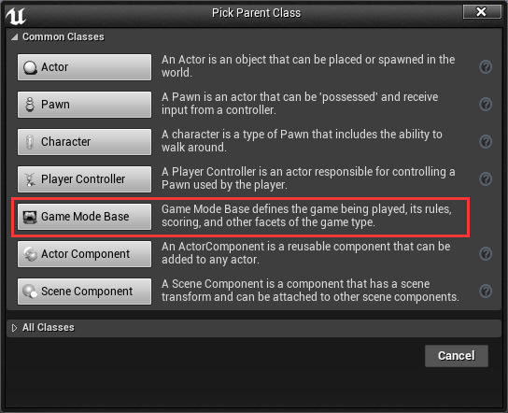

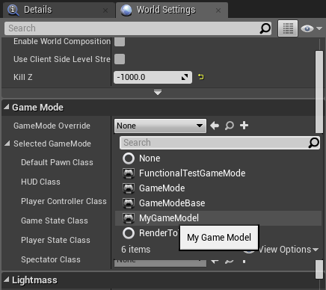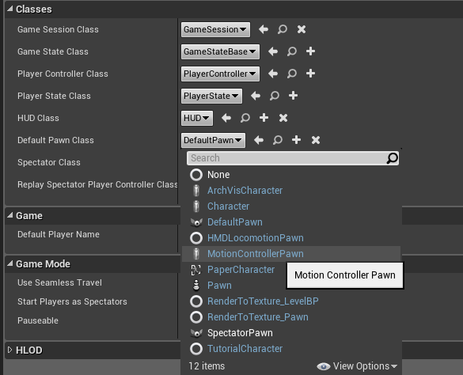

**7.After completing the above content, basic movement can be realized. For the convenience of debugging, the following nodes can be added to the Pawn class.**

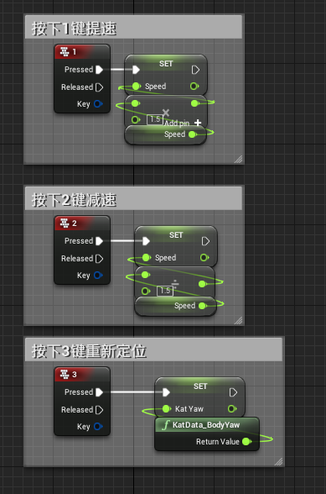

**8.Set before packing:**

Note: None of the paths in the package folder should have a Chinese name or they won’t be packed properly.

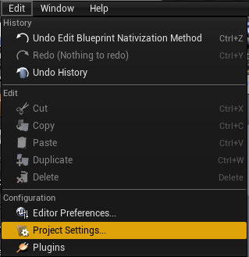

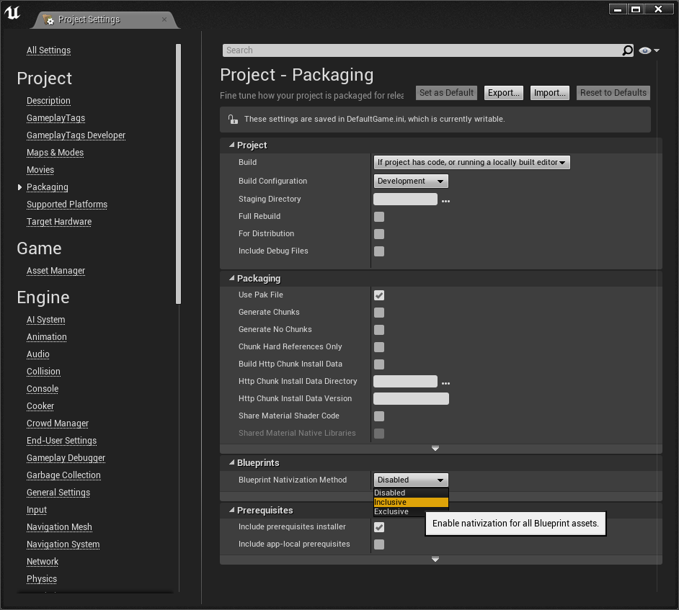

9.After having finished the packing, please insert the plugin into the corresponding folder.

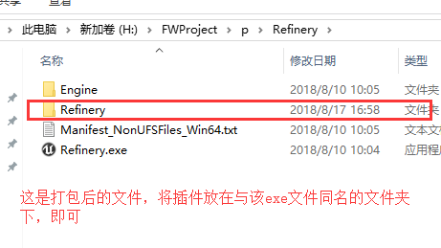

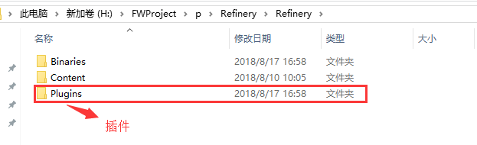

Note: The 4.18 and 4.24 version of the project files contained in this file are temporarily made by my personal test plug-in. The blueprint settings are for reference only; the packaged .exe file can be used as a detection machine (Mini or Walk) and corresponding Whether the runtime takes effect.

If you need technical support, please contact us

Official website: www.kat-vr.com

mail:service@katvr.com